

#### HUMAN BIOLOGICAL SCIENCES STAGE 2

## **GENETICS**

**EXTENDED RESPONSE 5**

Name: ___________________________________

1. In humans, a dominant allele ‘A’ produces astigmatism while normal vision is produced by a recessive allele ‘a**’**. In the pedigree below, shaded symbols represent individuals with astigmatism and open symbols represent individuals with normal vision.

1

2

3

4

5

6

I

II

III

2

1

1

2

3

4

5

(a) Complete the information for each individual listed in the table below. (2)

|  |  |  |  |
| --- | --- | --- | --- |
| Individuals | Phenotype | Sex | Genotype/s |
| I-1 | ***Affected*** | ***F*** | ***Aa*** |
| III-2 | ***Unaffected*** | ***M*** | ***aa*** |

(b) Parents II-1 and II-2, have three children with normal vision (III-1, III-2 and III-3) what is the probability of this occurring? (1)

***0.253 = 0.0156 (or 1/64)***

(c) A student examined the pedigree and made the following statement:

*“There is evidence on the pedigree that this condition could be inherited as a sex-linked condition.”*

Is this statement correct? Use evidence from the pedigree to support your answer.

(2)

***Not correct [1]***

***If the disease was transmitted as an X-linked dominant, then all daughters of affected***

***fathers would be affected. This is not the case with II2 and III3. [1]***

2. Red-green colour deficiency in human vision occurs in about 8% of males and 1% of females. The following pedigree shows its inheritance in one particular family.

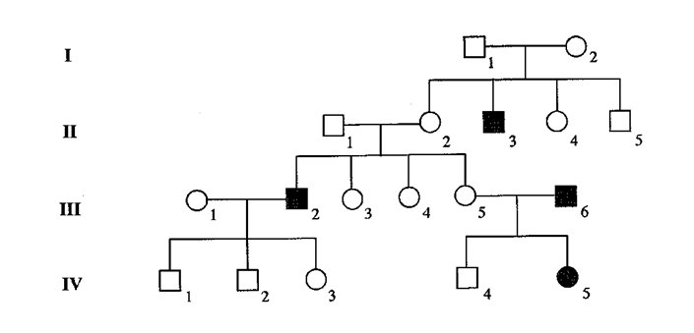

1. The allele for this condition is sex-linked. Explain the term “sex-linked”. (1)

***The defective gene is carried on one of the sex chromosomes***

1. Use evidence from the pedigree to identify whether the allele is recessive or dominant.

(2)

***Recessive [1]***

***Unaffected parents (I.1 and I.2) have and affected child (II.3) [1]***

1. Use the letters B and b to show the genotypes of:

Individual I.2 _________XB Xb_________________ (1)

Individual III.6 _________Xb Y__________________ (1)

Individual IV.3 _________ XB Xb ________________ (1)

1. Determine the possible genotypes and phenotypes in the children of individual III.5 and III.6. Show your working. (3)

***III.5 = XB Xb XB Xb / XB Y / Xb Xb / Xb Y [1]***

***III.6 = Xb Y carrier female / unaffected male / affected female / affected male [1]***

***Working (e.g. punnet square) [1]***

3. The ABO blood grouping system displays two phenomena in genetics. Explain the following terms and give an example using the ABO system.

1. Multiple alleles (2)

***More than two alleles are possible for one gene locus [1]***

***There are three allele A, B and O (or IA, IB and i) [1]***

1. Co-dominance (2)

***Both alleles are equally expressed in the phenotype [1]***

***Blood group AB [1]***

(c) Consider the pedigree shown below.

A

?

B

List the possible genotypes for the father’s blood type.

***AB, BB and BO (or IAIB, IBIB and IBi) [1-2 genotypes = 1 mark, all 3 genotypes = 2 marks]***

(2)

END OF ASSESSMENT